Due to the difference in PRC curve, the setup of thresholds based on the recall and precision is not very reasonable:

1. Here the r = 0.96, p = 0.9
2. Result:  
   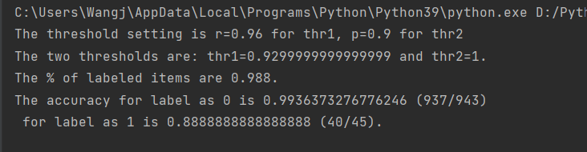
   1. Thresholds are 0.9299 and 1
   2. Incorrect label:  
      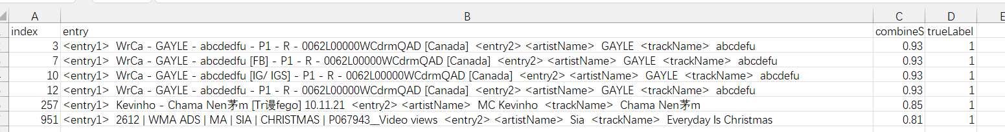
      1. The first several scores ~ 0.93 should be categorized as 1!
3. Discussion:
   1. It’s hard to control the threshold with r and p:
      1. Sometimes the threshold corresponding to r and p are overlapped:
         1. From r should gives us the lower threshold thr1, and from p should gives us the higher threshold thr2
         2. Sometime thr1 is larger than thr2 due to the improper selection of r and p
4. Proposal:
   1. Directly set the thresholds
      1. Benefit:
         1. There won’t be overlap thr anymore
         2. Easy to control the two thr
      2. \*maybe also report the corresponding r and p?